### Tune

#### Tune table

The “Tune table” settings allows the user to fine-tune the output of a sender.  
 **Example 1: Sensor value too low.**  
In such a case you must change the second input value. You can change the input value as follows:Input value= 0.8 → Real value = 1.  
The statement above implies that for every input of 0.8 bar the output (actual reading) is 1 bar. In other words, any sensor input value of 4 bar corresponds with an instrument reading of 5 bar.   
  
**Example 2: Sensor value too high.**Change the input value as follows:  
Input value = 1.2 → Real value = 1.  
The statement above implies that for every input of 1.2 bar the output (actual reading) is 1 bar. In other words, any sensor input value of 5 bar corresponds with an instrument reading of around 4 bar.   
For threshold values you can change the first input value. If the pressure indication has to start later than given, you can put in “Input value = 0.2 → Real value = 0”   
This will make the instrument starts displaying as soon as the threshold of 0.2 bar has been reached. This can be accomplished the other way around.

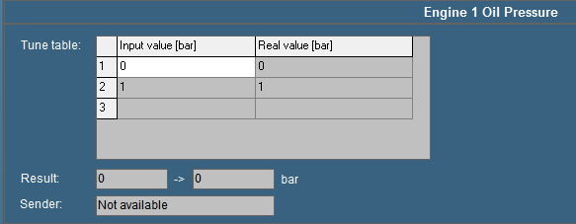

Figure 11‑16: Tune table

#### Result

The “Result” box displays the exact incoming measuring data. The second box displays this data via the respective instrument that is connected to the sensor.   
If for example the sensor gives a pressure (bar) output for every 20 mV, the real time result may read “100 → 5 bar” (see Figure 11‑16). As a result the sensor reads “100 mV” and indicated as “5 bar” on the instrument.

*:*

*Values may differ per sensor type.*

#### Sender

The “Sender” box (see Figure 11‑17) displays the device name where the data is coming from. If the sender field shows “Not available” indicates that that the sensor isn’t giving any data (for a reason why it is not giving data, check the troubleshooting section).   
Other items you can see in the box “sender” are: NMEA, Wago, Serial, Modbus, Calculated in, etc. this gives you an indication where the signal is coming from.

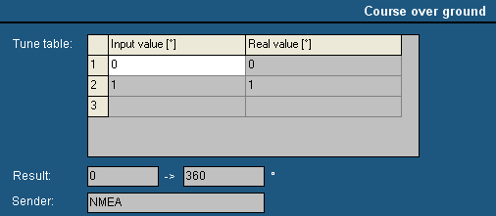

Figure 11‑17: Sender box